Dear Members of the Congress:

As a chronic pain patient, I am writing to you to request you to take action to provide a permanent solution to the recurring physician payment cuts. Please maintain my access to care by preventing Medicare Payment Cuts. The Medicare payment cuts for physicians in 2024 include:

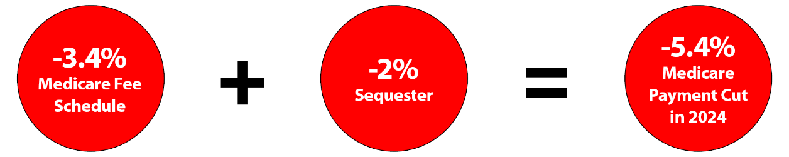

Medicare Physician Fee Schedule Cuts = -3.4%
• The Centers for Medicare and Medicaid Services have implemented a -3.4% decrease in payments in 2024 for services under the Medicare Physician Fee Schedule.
• Medicare physician payment has been reduced 26% adjusted for inflation from 2001–2023.

Medicare Sequestration = -2%
• Medicare sequestration of -2% now has been extended through 2032, because of temporary delay for 1½ years.

If Congress does not act, a sequestration order will be issued within 15 days of the end of the congressional session, and Medicare reimbursements will be reduced by 4%, beginning in January 2024. Please take action to preserve my access to care.

Sincerely,

________________________________________________________
Signature

_________________________________________________________
Printed Full Name

___________________________________________________________
City, State, and ZIP Code

________________________________________________________
Email address

Date: ___________________________

