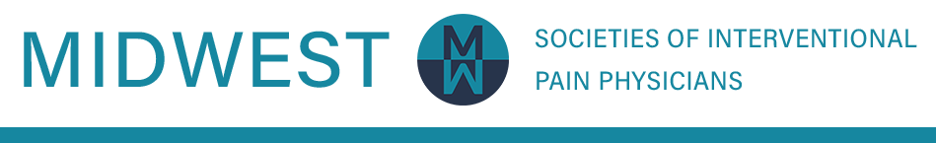

Midwest Societies of Interventional Pain Physicians
November 11-13, 2022
Palmer House Hilton
Chicago, IL

CALL FOR ABSTRACTS

Submission Deadline Extended: October 31, 2022
The Planning Committee for the Midwest Societies of Interventional Pain Physicians Regional Meeting invites you to submit abstracts for papers to be presented at the upcoming conference at The Palmer House Hilton in Chicago, IL. Abstracts should describe original research in the field of pain management. We welcome residents and fellows to submit abstracts as well.

General Information:
We have reserved time on the program for scientific poster sessions. Posters will be available for viewing throughout the entirety of the conference. You are welcome and encouraged to bring handouts. Poster specifications will be listed on this form soon.
Abstracts previously presented or published may not be submitted without modifications, original work must be changed or expanded, resulting in a new abstract.
The Planning Committee will retain the copyright of the published abstracts. Awards will be presented to the top poster presenters.

Submission Information:
Submit all abstract applications using the online form.

CLICK HERE FOR FORM

Please use the recommended abstract format:

Introduction/Statement of the Problem, Materials and Methods, Results, and Conclusions. The text of your abstract may be up to 300 words total. All correspondence will be sent to the presenting author.
- In 300 words or less, provide an accurate, succinct, and informative representation of the content that will be presented in the paper. The abstract communicates the essence of the presentation to the in- tended audience.
- Do not use abbreviations. Type in sentence case. Do not type in all caps.
- Do not use the ampersand character (&) unless it is part of the company name.
- Proofread for typographical, grammar, and syntax errors.

Policy on Commercial Support:

Presentations must avoid commercialism. Presentations that constitute promotion and advertising will not be accepted. If the cost of a presentation has been underwritten to any extent, a clear acknowledgement stating the support and identifying the source should be included in the abstract (e.g., “The support of
[corporation or institution] for this project is gratefully acknowledged.”). Statements made in presentations are the sole responsibility of the author or presenter. Statements should not be viewed as or considered representative of any formal stance or position taken on any subject, issue, or product by the CASIPP 2022 Planning Committee.

Selection Criteria:
Submissions will be reviewed and rated by members of the Scientific Planning Committee who have expertise in the clinical area to which the submission belongs. Each submission will be reviewed for its scientific or clinical importance, ethical practice, and study design.
Presenters will be required to complete a presenter information form.

Primary presenters will be notified by e-mail of the proposal’s acceptance or rejection by October 11, 2022

Meeting Registration Guideline for Presenters:
Poster presenters must register for the meeting and pay the applicable registration fee, as the MIDWEST 2022 Conference will not waive the registration fee. Presenters are also responsible for all personal expenses (e.g., travel, hotel). You are encouraged to register for the meeting and to reserve hotel accommodations as early as possible to ensure that space is available.
For Registration and Hotel Information, please contact the planning committee at:

Karen Avery kavery@asipp.org

Poster Guidelines:

Specific space will be assigned to display your materials. Abstracts will be displayed beginning prior to the first break of the conference. Presenters for poster presentations may be present at the assigned time to present their materials. Your information should be self-explanatory so that you are free to supplement and discuss particular points raised by viewers. Again, handouts are strongly encouraged. You should bring enough handouts to insure availability to all attendees.

Click here to submit your abstract application. Direct questions to:

MIDWEST Abstracts Savannah Gold sgold@asipp.org

