Table 1. Characteristics of the Medicare beneficiaries and epidural procedures excluding percutaneous adhesiolysis, continuous epidurals, and neurolytic epidurals.

Year | U.S. Population  (thousands)  (Percent) # | Medicare  Beneficiaries  (thousands)  (Percent)# | Epidural Services*
 |  |  | Services  (all Codes) |  | PCPY |  | Rate |  | PCPY |  | Services  (Primary codes only) |  | Rate |  | PCPY
Y2000 | 282,172  (12.40%) | 39,632  (86.50%) | 839,474 |  |  |  | 2,118 |  |  |  | 792,563 |  | 2,000
Y2010 | 308,746  (13.00%) | 46,914  (83.11%) | 2,205,307 |  | 4.4% |  | 4,701 |  | 1.9% |  | 1,792,291 |  | 3,820 |  | 0.9%
Y2011 | 311,583  (13.28%) | 48,300  (82.82%) | 2,289,213 |  | 3.8% |  | 4,740 |  | 0.8% |  | 1,864,066 |  | 3,859 |  | 1.0%
Y2012 | 313,874  (13.75%) | 50,300  (83.30%) | 2,304,993 |  | 0.7% |  | 4,582 |  | -3.3% |  | 1,892,951 |  | 3,763 |  | -2.5%
Y2013 | 316,129  (14.14%) | 51,900  (83.04%) | 2,259,887 |  | -2.0% |  | 4,354 |  | -5.0% |  | 1,854,380 |  | 3,573 |  | -5.1%
Y2014 | 318,892  (14.48%) | 53,500  (83.36%) | 2,255,668 |  | -0.2% |  | 4,216 |  | -3.2% |  | 1,826,336 |  | 3,414 |  | -4.5%
Y2015 | 320,897  (14.88%) | 54,900  (83.79%) | 2,276,267 |  | 0.9% |  | 4,146 |  | -1.7% |  | 1,845,604 |  | 3,362 |  | -1.5%
Y2016 | 323,127  (15.24%) | 56,500  (84.07%) | 2,316,285 |  | 1.8% |  | 4,100 |  | -1.1% |  | 1,882,269 |  | 3,331 |  | -0.9%
Y2017 | 326,625  (15.63%) | 58,000  (84.83%) | 2,247,240 |  | -3.0% |  | 3,875 |  | -5.5% |  | 1,835,796 |  | 3,165 |  | -5.0%
Y2018 | 327,167  (16.0%) | 59,600  (85.23%) | 2,186,893 |  | -2.7% |  | 3,669 |  | -5.3% |  | 1,788,915 |  | 3,002 |  | -5.2%
Y2019 | 328,293  (16.47%) | 61,200  (85.95%) | 2,184,917 |  | -0.1% |  | 3,570 |  | -2.7% |  | 1,784,870 |  | 2,916 |  | -2.8%
Y2020 | 331,002  16.90%) | 62,600  (86.42%) | 1,810,884 |  | -17.1% |  | 2,893 |  | -19.0% |  | 1,473,789 |  | 2,354 |  | -19.3%
Percentage of Change from
2000-2020 | 17.3% | 58.0% | 115.7% |  |  |  | 36.6% |  |  |  | 86.0% |  | 17.7%
GM | 0.8% | 2.3% | 3.9% |  |  |  | 1.6% |  |  |  | 3.2% |  | 0.8%
2000-2010 | 9.4% | 18.4% | 162.7% |  |  |  | 121.9% |  |  |  | 126.1% |  | 91.0%
GM | 0.9% | 1.7% | 10.1% |  |  |  | 8.3% |  |  |  | 8.5% |  | 6.7%
2010-2019 | 6.3% | 30.5% | -0.9% |  |  |  | -24.1% |  |  |  | -0.4% |  | -23.7%
Change | 0.7% | 3.0% | -0.1% |  |  |  | -3.0% |  |  |  | 0.0% |  | -3.0%
2010-2020 | 7.2% | 33.4% | -17.9% |  |  |  | -38.5% |  |  |  | -17.8% |  | -38.4%
GM | 0.7% | 2.9% | -2.0% |  |  |  | -4.7% |  |  |  | -1.9% |  | -4.7%
2019-2020 | 0.8% | 2.3% | -17.1% |  |  |  | -19.0% |  |  |  | -17.4% |  | -19.3%

Rate – Rate per 100,000 Medicare beneficiaries, GM - Geometric average change # (percentage of >= 65 years old) (annual change indicates the central tendency or typical value of a set of numbers by using the product of their values as opposed to the arithmetic mean, which uses their sum).

PCPY: percentage change per year

Epidural Services = 62310, 62320, 62321 C/T or interlaminar epidural injections; 62311, 62322, 62323-L/S interlaminar epidural injections; 64479- C/T transforaminal epidural injections; 64480- C/T transforaminal epidural injections add-on; 64483-L/S transforaminal epidural injections; 64484-L/S transforaminal epidural injections add-on

Table 2. Utilizations of epidural injections in the fee-for-service Medicare population from 2000-2020.

 | Cervical/Thoracic Interlaminar Epidurals  (CPT 62310, 62321) |  | Lumbar Interlaminar and Caudal Epidurals (CPT 62311, 62323) |  | Cervical/Thoracic  Transforaminal Epidurals  (CPT 64479, 64480) |  | Lumbar/Sacral  Transforaminal Epidurals  (CPT 64483, 64484)
Year | Services | Rate | Services | Rate | Services | Rate | Services | Rate
2000 | 75,741 | 191 | 618,362 | 1,560 | 22,888 | 58 | 122,483 | 309
2010 | 184,750 | 394 | 888,421 | 1,894 | 69,891 | 149 | 1,062,245 | 2,264
2011 | 200,134 | 414 | 914,324 | 1,893 | 65,598 | 136 | 1,109,157 | 2,296
2012 | 213,390 | 424 | 925,179 | 1,839 | 57,238 | 114 | 1,109,186 | 2,205
2013 | 217,393 | 419 | 901,468 | 1,737 | 55,108 | 106 | 1,085,918 | 2,092
2014 | 208,741 | 390 | 815,858 | 1,525 | 59,531 | 111 | 1,171,538 | 2,190
2015 | 215,897 | 393 | 820,227 | 1,494 | 58,970 | 107 | 1,181,173 | 2,151
2016 | 224,118 | 397 | 824,822 | 1,460 | 59,208 | 105 | 1,208,137 | 2,138
2017 | 223,060 | 385 | 788,456 | 1,359 | 56,563 | 98 | 1,179,161 | 2,033
2018 | 220,470 | 370 | 751,846 | 1,261 | 54,435 | 91 | 1,160,142 | 1,947
2019 | 221,462 | 362 | 737,394 | 1,205 | 54,048 | 88 | 1,172,013 | 1,915
2020 | 183,699 | 293 | 596,369 | 953 | 45,149 | 72 | 985,667 | 1,575
Change from
2000-2020 | 142.5% | 53.5% | -3.6% | -38.9% | 97.3% | 24.9% | 704.7% | 409.5%
Rate | 4.5% | 2.2% | -0.2% | -2.4% | 3.5% | 1.1% | 11.0% | 8.5%
2000-2010 | 143.9% | 106.1% | 43.7% | 21.4% | 205.4% | 158.0% | 767.3% | 632.6%
Rate | 8.2% | 6.5% | 2.4% | 0.8% | 11.6% | 9.9% | 19.5% | 17.6%
2010-2019 | 19.9% | -8.1% | -17.0% | -36.4% | -22.7% | -40.7% | 10.3% | -15.4%
Rate | 2.0% | -0.9% | -2.0% | -4.9% | -2.8% | -5.6% | 1.1% | -1.8%
2010-2020 | -0.6% | -25.5% | -32.9% | -49.7% | -35.4% | -51.6% | -7.2% | -30.5%
Rate | -0.1% | -2.9% | -3.9% | -6.6% | -4.3% | -7.0% | -0.7% | -3.6%
2019-2020 | -17.1% | -18.9% | -19.1% | -20.9% | -16.5% | -18.3% | -15.9% | -17.8%

Epidural Services = 62310, 62320, 62321 C/T or interlaminar epidural injections; 62311, 62322, 62323-L/S interlaminar epidural injections

Table 3. Utilization patterns of epidural injections by various specialty groups from 2000 to 2020 in Medicare recipients.

 | Interventional Pain Management # |  | Surgical (Neuro, General, & Orthopedic) |  | Radiology |  | General Physicians |  | Other Providers  (CRNA, NP & PA) |  | Total
Specialty | Services | Rate | Services | Rate | Services | Rate | Services | Rate | Services | Rate | Services | Rate
2000 | 702,731  (83.7%) | 1,773 | 47,213  (5.6%) | 119 | 22,794  (2.7%) | 58 | 52,429  (6.2%) | 132 | 14,307  (1.7%) | 36 | 839,474 | 2,118
2010 | 1,911,762  (86.7%) | 4,075 | 126,119  (5.7%) | 269 | 83,670  (3.8%) | 178 | 65,610  (3.0%) | 140 | 18,146  (0.8%) | 39 | 2,205,307 | 4,701
2011 | 2,008,135  (87.7%) | 4,158 | 117,001  (5.1%) | 242 | 87,447  (3.8%) | 181 | 58,974  (2.6%) | 122 | 17,656  (0.8%) | 37 | 2,289,213 | 4,740
2012 | 2,038,618  (88.4%) | 4,053 | 111,135  (4.8%) | 221 | 88,123  (3.8%) | 175 | 50,243  (2.2%) | 100 | 16,874  (0.7%) | 34 | 2,304,993 | 4,582
2013 | 2,008,620  (88.9%) | 3,870 | 103,000  (4.6%) | 198 | 82,766  (3.7%) | 159 | 49,848  (2.2%) | 96 | 15,653  (0.7%) | 30 | 2,259,887 | 4,354
2014 | 2,019,328  (89.5%) | 3,774 | 100,658  (4.5%) | 188 | 82,257  (3.6%) | 154 | 39,876  (1.8%) | 75 | 13,549  (0.6%) | 25 | 2,255,668 | 4,216
2,015 | 2,045,138  (89.8%) | 3,725 | 100,262  (4.4%) | 183 | 81,034  (3.6%) | 148 | 36,088  (1.6%) | 66 | 13,745  (0.6%) | 25 | 2,276,267 | 4,146
2,016 | 2,086,614  (90.1%) | 3,693 | 97,656  (4.2%) | 173 | 82,397  (3.6%) | 146 | 34,722  (1.5%) | 61 | 14,896  (0.6%) | 26 | 2,316,285 | 4,100
2,017 | 2,028,083  (90.2%) | 3,497 | 92,546  (4.1%) | 160 | 81,559  (3.6%) | 141 | 31,275  (1.4%) | 54 | 13,777  (0.6%) | 24 | 2,247,240 | 3,875
2,018 | 1,980,578  (90.6%) | 3,323 | 88,170  (4.0%) | 148 | 76,959  (3.5%) | 129 | 27,527  (1.3%) | 46 | 13,659  (0.6%) | 23 | 2,186,893 | 3,669
2,019 | 1,976,335  (90.5%) | 3,229 | 87,605  (4.0%) | 143 | 78,160  (3.6%) | 128 | 28,176  (1.3%) | 46 | 14,641  (0.7%) | 24 | 2,184,917 | 3,570
2,020 | 1,643,271  (90.7%) | 2,625 | 73,261  (4.0%) | 117 | 58,491  (3.2%) | 93 | 24,314  (1.3%) | 39 | 11,547  (0.6%) | 18 | 1,810,884 | 2,893
2000-2020 | 133.8% | 48.0% | 55.2% | -1.8% | 156.6% | 62.5% | -53.6% | -70.6% | -19.3% | -48.9% | 115.7% | 36.6%
GM | 4.3% | 2.0% | 2.2% | -0.1% | 4.8% | 2.5% | -3.8% | -5.9% | -1.1% | -3.3% | 3.9% | 1.6%
2000-2010 | 172.0% | 129.8% | 167.1% | 125.7% | 267.1% | 210.1% | 25.1% | 5.7% | 26.8% | 7.1% | 162.7% | 121.9%
GM | 10.5% | 8.7% | 10.3% | 8.5% | 13.9% | 12.0% | 2.3% | 0.6% | 2.4% | 0.7% | 10.1% | 8.3%
2010-2019 | 3.4% | -20.8% | -30.5% | -46.8% | -6.6% | -28.4% | -57.1% | -67.1% | -19.3% | -38.1% | -0.9% | -24.1%
GM | 0.4% | -2.6% | -4.0% | -6.8% | -0.8% | -3.6% | -9.0% | -11.6% | -2.4% | -5.2% | -0.1% | -3.0%
2010-2020 | -14.0% | -35.6% | -41.9% | -56.5% | -30.1% | -47.6% | -62.9% | -72.2% | -36.4% | -52.3% | -17.9% | -38.5%
GM | -1.5% | -4.3% | -5.3% | -8.0% | -3.5% | -6.3% | -9.4% | -12.0% | -4.4% | -7.1% | -2.0% | -4.7%
2,019 | -16.9% | -18.7% | -16.4% | -18.2% | -25.2% | -26.8% | -13.7% | -15.6% | -21.1% | -22.9% | -17.1% | -19.0%

Rate - Per 100,000 Medicare Beneficiaries; GM: Geometric change (Annual change indicates the central tendency or typical value of a set of numbers by using the product of their values as opposed to the arithmetic mean, which uses their sum)
IPM (Interventional Pain Management): Anesthesiology, Pain Management, PM&R, Neurology, Psychiatry,
General Physicians: Family Practice, General Practice & Internal Medicine
(%) – percentage to total

Table 4. Utilizations of epidural injections (rates per 100,000) in the Medicare population from 2010-2020.

Carrier | R2010 | R2011 | R0212 | R2013 | 3R2014 | R2015 | R2016 | R2017 | R2018 | R2019 | R2020 | 2010-2019 | Rate | 2010-2020 | GM | 2019-20
CGS | 4,404 | 4,415 | 4,359 | 4,097 | 3,831 | 3,711 | 3,753 | 3,551 | 3,326 | 3,191 | 2,531 | -27.5% | -3.5% | -42.5% | -5.4% | -20.7%
PCPY | -2.1% | 0.2% | -1.3% | -6.0% | -6.5% | -3.1% | 1.1% | -5.4% | -6.3% | -4.1% | -20.7%
Cahaba | 5,525 | 5,797 | 5,817 | 5,286 | 5,131 | 5,266 | 5,034 | 4,524 | 4,202 | 4,120 | 3,335 | -25.4% | -3.2% | -39.6% | -4.9% | -19.1%
PCPY | -4.9% | 4.9% | 0.3% | -9.1% | -2.9% | 2.6% | -4.4% | -10.1% | -7.1% | -1.9% | -19.1%
Palmetto | 4,806 | 5,069 | 5,114 | 4,933 | 4,704 | 4,774 | 4,655 | 4,391 | 4,219 | 4,197 | 3,520 | -12.7% | -1.5% | -26.8% | -3.1% | -16.1%
PCPY | 1.6% | 5.5% | 0.9% | -3.5% | -4.6% | 1.5% | -2.5% | -5.7% | -3.9% | -0.5% | -16.1%
First Coast | 5,793 | 5,707 | 5,456 | 5,074 | 4,970 | 5,017 | 4,767 | 4,322 | 4,148 | 4,023 | 3,418 | -30.5% | -4.0% | -41.0% | -5.1% | -15.0%
PCPY | -2.1% | -1.5% | -4.4% | -7.0% | -2.0% | 1.0% | -5.0% | -9.3% | -4.0% | -3.0% | -15.0%
Novitas | 5,281 | 5,342 | 5,142 | 5,014 | 4,973 | 5,088 | 4,848 | 4,458 | 4,169 | 4,098 | 3,307 | -22.4% | -2.8% | -37.4% | -4.6% | -19.3%
PCPY | 2.0% | 1.1% | -3.7% | -2.5% | -0.8% | 2.3% | -4.7% | -8.1% | -6.5% | -1.7% | -19.3%
NGS | 3,573 | 3,626 | 3,620 | 3,565 | 3,471 | 3,466 | 3,342 | 3,149 | 2,958 | 2,958 | 2,306 | -17.2% | -2.1% | -35.4% | -4.3% | -22.0%
PCPY | 2.9% | 1.5% | -0.2% | -1.5% | -2.6% | -0.2% | -3.6% | -5.8% | -6.1% | 0.0% | -22.0%
Noridian | 3,830 | 3,948 | 4,010 | 3,961 | 3,763 | 3,824 | 3,552 | 3,261 | 3,193 | 3,150 | 2,583 | -17.8% | -2.1% | -32.6% | -3.9% | -18.0%
PCPY | 4.8% | 3.1% | 1.6% | -1.2% | -5.0% | 1.6% | -7.1% | -8.2% | -2.1% | -1.4% | -18.0%
WPS | 5,791 | 5,611 | 5,515 | 5,293 | 5,091 | 4,990 | 4,705 | 4,275 | 4,017 | 3,843 | 3,011 | -33.6% | -4.5% | -48.0% | -6.3% | -21.7%
PCPY | 7.2% | -3.1% | -1.7% | -4.0% | -3.8% | -2.0% | -5.7% | -9.1% | -6.1% | -4.3% | -21.7%
US Total | 4,701 | 4,740 | 4,582 | 4,354 | 4,216 | 4,146 | 4,100 | 4,013 | 3,669 | 3,570 | 2,893 | -24.1% | -3.0% | -38.5% | -4.7% | -19.0%
PCPY | 1.9% | 0.8% | -3.3% | -5.0% | -3.2% | -1.7% | -1.1% | -2.1% | -8.6% | -2.7% | -19.0%
GM: Geometric change (Annual change indicates the central tendency or typical value of a set of numbers by using the product of their values as opposed to the arithmetic mean, which uses their sum)

PCPY: percentage change from previous year

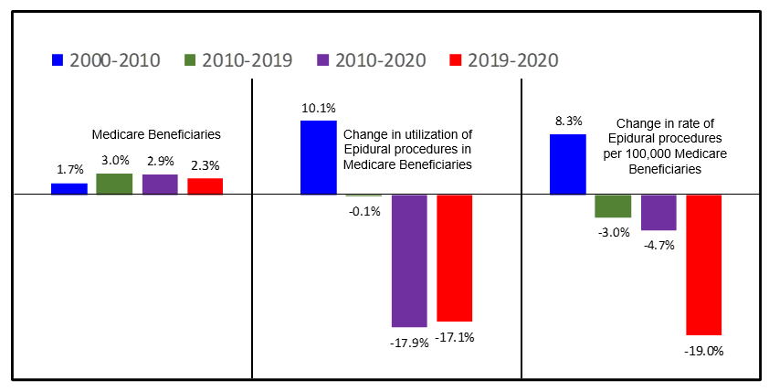

Fig. 1. Analysis of annual growth in the Medicare beneficiaries of utilization of epidural services and rate per 100,000 Medicare beneficiaries.

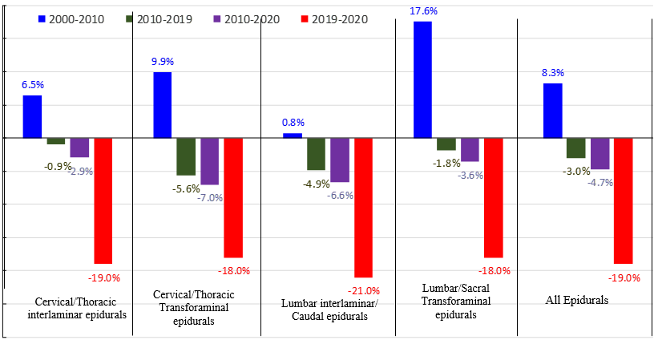

Fig 2. Change in the rate of frequency of utilization of epidural injections (annual change) per 100,000 Medicare beneficiaries stratified by the type of procedure.

Fig. 3. Analysis of frequency of utilization of growth of epidural procedures (all procedures, including the add-on codes) stratified by type of procedure from 2000 to 2020 in Medicare beneficiaries.

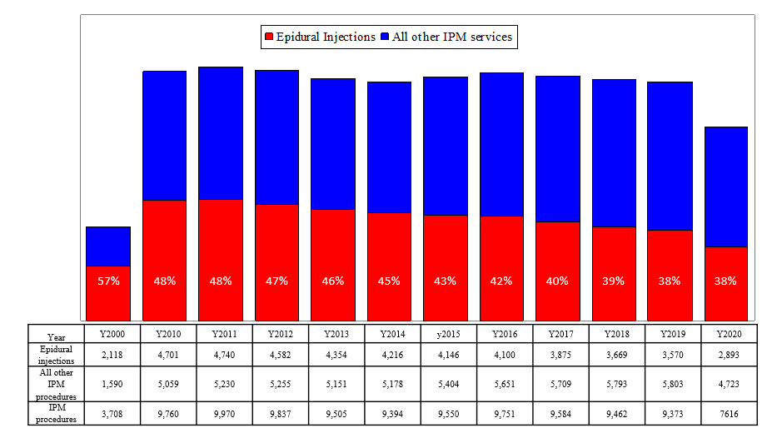
Fig. 4. Analysis of annual rates of growth of epidural procedures (all procedures, including the add-on codes) compared to utilization of all other interventional pain management services as shown in reference (3).

